Rocks and Minerals
1) __________ rocks - formed when sand, dirt, and other materials are squeezed together until they harden. Fossils are sometimes present.
2) __________ rocks - were once melted and then cooled. They are formed form magma (lava).
3) __________ rocks - formed by heat and pressure.

4) Rock Cycle – Label A, B and C and then explain what each type of rock can become.
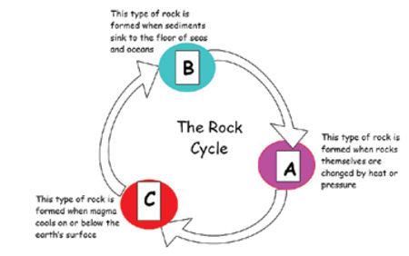
5) Rocks & __________ can be classified using physical attributes such as color, shape, texture, & hardness. Minerals are non-living solid, non-living objects formed in nature. Rocks are naturally formed solid made of one or more minerals.

Weathering/Erosion/Deposition
6) Chemical or Mechanical – Weathering of rock caused by freezing and thawing, animal actions, growth of plant roots and erosion.
7) Chemical or Mechanical – Weathering caused by water, oxygen (oxidation), carbon dioxide (carbonic acid), living organisms (make weak acids) and acid rain.

Weathering/Erosion/Deposition
8) ___________ breaks down rock. __________moves rock that has been broken down. __________ is the resting place for rock that has been weathered and moved.
9) _____________ is the process where wind and rain wash ________ away, making it difficult for plants to grow and survive.
10) ____________ is the movement of weathered rock and soil. Moving _______ is the cause of most weathering.

Soil Horizons = Soil Layers = Soil Profile
11) Soil is the loose material in which plants can grow in the _________ of the Earth. Soil is a mixture of four different materials: tiny pieces of ________, ________,________ and ________.
12) Soil is considered a(n) ________________resource and very important to humans because it takes close to 500 – 1,000 years to make _____ inch of soil.
13) Use the word bank to label each part
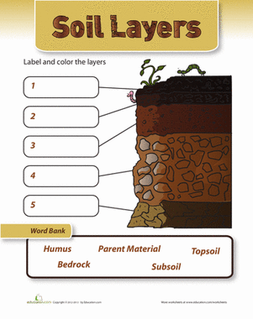
14) ________ is the part of soil made up of decayed living things. Plants absorb minerals from the soil. We then ________ the plants, which gives us the minerals that are found in soil.
15) ________ is an important part of soil. The plants take it in through the soil.

Soil Porosity and Permeability
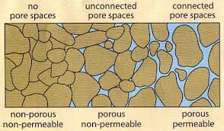
16) __________ is a property of soil too. We learned about sand, silt, and clay and their ability to retain water.
17) Types of Soil - ________ is made up of very small powdery grains and has small spaces between the grains which holds lots of water, making it sticky and difficult for plants to grow. ________ has large grains. This allows water to drain quickly, which keeps most plants from getting enough water.
18) ________ is a type of topsoil and used on farms. It is rich with humus and holds water and air well, making it ideal for plants to grow. This type of soil is usually dark brown or black.

Soil Type and What Determines the Rate of Soil Formation
19) Soil is __________ from place to place because of the different materials found in the soil. The soil from your yard will look different from soil from your classmate’s yard and contains different materials.
20) Soil comes in different colors. Soil is different colors because of the different minerals and materials found in soil. Example: Soil in North Carolina is a reddish-orange color because it is rich in ________.
21) Soil has different ________. You should be able to use different words to describe soil, such as; rough, sticky, rocky, sandy, gritty, smooth, etc.
22) Explain how climate (temperature/precipitation) and type of parent rock determine how slowly or quickly soil forms.

Human Interactions –Consequences of Poor Soil Management
23) What was the Dust Bowl and how did it happen?

Human Interactions - Soil Conservation
24) What is soil conservation? Why is it important?

25) How can plants help prevent soil erosion?

26) Matching
A.  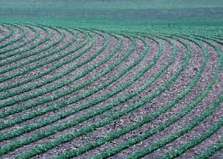 | B.  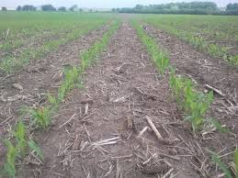 | C.  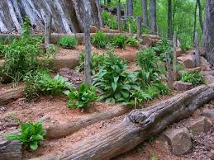
*Plow along curve of a slope  *Prevent rain water from washing  away topsoil | *Disturb plants as little as possible  *Dead plants are tilled into the  ground so it can be used for  nutrients by the soil. | * Graduated steps are commonly used  to farm on hilly or mountainous terrain  * Decrease erosion and surface runoff
D.  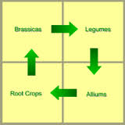 | E.  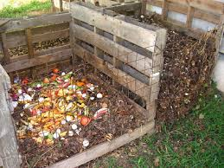 | Use the words below to match  the image, explanation and word
*Plant different crops from one year to the next  *Prevent nutrient depletion  *Prevents build-up of pests in soil | *Simple way to add nutrient-rich humus  To depleted soil  *Fuels plant growth and restores vitality  to depleted soil. | Composting  Crop rotation  Conservation plowing  Contour plowing  Terracing

27) Explain remote sensing and why it is used for soil?

