Earthquakes Venn Diagram Name____________________
- Compare and contrast two earthquakes

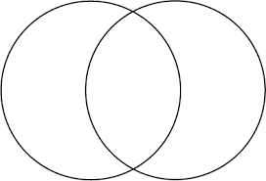

Ideas to Consider – Year, epicenter location, type of plate boundary, location, magnitude, deaths, cost of destruction

